Prediction of YouTube Video Popularity Using a GWO-Transformer Model
Yuqing Gong
Shenzhen College of International Education,Shenzhen,China
18300048662@163.com

Abstract: Given the increasing importance of online video sites, YouTube video popularity prediction has become crucial in terms of content recommendation, user behavior understanding, and optimal platform management. Video popularity dynamics usually have a nonlinear nature, are temporally correlated and bursty, and cannot be handled appropriately by standard models. In this regard, this paper presents a model of YouTube video popularity prediction that uses the combination of Grey Wolf Optimizer (GWO) and Transformer, namely GWO-Transformer. As can be seen, the methodology is based on two stages. First, the self-attention component of Transformer is used to capture long-term dependencies and global temporal features of video popularity time series. Second, GWO is applied to optimize the hyperparameters of Transformer for the sake of improvement of the training procedure. An experimental evaluation of the proposed methodology is carried out through a comparison of its performance in the task of YouTube video popularity prediction with several traditional machine learning and deep learning approaches for forecasting.
Keywords: YouTube videos; popularity prediction; Transformer; Grey Wolf Optimizer; time-series forecasting

1 Introduction
In response to the development of video streaming services and social networking sites, YouTube videos have emerged as one of the important means for information dissemination, brand marketing, knowledge sharing, and spreading opinions among people. Video popularity is generally determined through parameters such as view counts, likes, shares, etc., along with the growth rate, and the entire process exhibits a certain degree of temporal dependence, nonlinearity, and burstiness. In accordance with previous literature findings, YouTube popularity does not emerge in an arbitrary fashion, and there are certain growth patterns that emerge at the beginning of the life cycle of the video, and various categories, sources, and external dissemination channels give rise to different lifecycle pathways [1-2]. Prediction of YouTube videos' popularity will assist content creators in planning video releases, and at the same time, it can be used as a basis for recommendation systems, advertisements, resource management, etc.
Popular video and social media content prediction research has seen progress from statistics models, to conventional machine learning models, and now deep learning models. Initially, the approaches depended on handcrafted features such as historical views, publication time, content type, title and tags, and adopted linear regression, support vector regression, or ensemble learning models [2-4]. However, although these models have relatively understandable nature, they cannot capture complex interaction between features, long-term temporal dependencies, and multivariate dependencies well. Deep neural network was then utilized to automatically discover nonlinear relationships among content features, user interaction features, and time series features [5-7]. DTCN models the evolution of the temporal context and temporal attention of social media popularity [6], DFTC makes full use of the temporal process and content features to enhance the online content prediction [7], and multi-feature fusion approaches focus on the importance of joint modeling of image, text, users and context [8]. With the advancement of technology in recent years, multimodal, fine-grained, and temporal structures are being more widely adopted in social media popularity prediction, while large benchmark datasets and competitions contribute to more standardized model architectures and evaluation protocol [9].
However, even in light of the progress made so far, there are some obstacles to predicting the popularity of videos from YouTube. The first one is the fact that YouTube popularity sequences usually have bursts of short-term popularity, periodicity, and long-term decay at the same time. Classic recurrent and convolutional approaches might be limited by gradient propagation, window size, and local receptive fields when modeling long-range dependencies. The second one is that YouTube popularity depends on many factors, including the content itself, title and tags, release date, channel, early engagement, and external environment. In other words, the hyperparameters play an important role in the performance of the model, while manually tuning them is difficult and often leads to sub-optimal results. Self-attention allows the Transformer to model global dependencies in a sequence parallelly [10], and it has shown good results in forecasting problems with long sequences [11-12]. At the same time, there are a lot of crucial hyperparameters in the Transformer, such as learning rate, number of layers, number of attention heads, hidden dimension, and batch size.
Grey Wolf Optimizer (GWO) is a type of swarm intelligence optimization algorithm which models the behavior of search and hierarchical encirclement by wolves. It possesses a simple architecture, efficient global search ability and a limited number of control parameters [13]. Some time series forecasting works have shown that the employment of GWO to optimize neural network parameters or hyperparameters can achieve better forecasting results [14]. In our work, the combination of GWO and Transformer, where GWO is utilized to seek key hyperparameters of the Transformer, will be beneficial.
Therefore, in this paper, a new GWO-Transformer method for predicting the popularity of videos in YouTube is proposed. The proposed model employs the popularity patterns together with their corresponding features for propagation as the input data set, makes use of the capabilities of the Transformer neural network architecture in terms of learning the global temporal dependencies in video popularity evolution, and performs the optimal tuning of the essential hyperparameters of the method by means of the GWO algorithm. Our contributions include the following points. First of all, a new Transformer-based video popularity prediction method based on the characteristics of the nonlinearity, burstiness, and temporal dependency of the video popularity process is proposed. Secondly, the GWO method is applied to the global tuning of important Transformer model parameters in order to minimize the influence of the tuning process on the performance of the method.

2 GWO-Transformer Methodology

2.1 Transformer Prediction Model
The core idea behind Transformers is the self-attention mechanism, which allows building links between any two points of time in a sequence without using recursion. Within the problem of YouTube video popularity prediction, the propagation state of the video at the current point of time could be affected not only by the most recent interactions but also by its very first interactions that happened when the video was uploaded for the first time, along with the overall channel influence and interaction peaks in history.
The input sequence $X$ is first projected into the model's latent space through a linear mapping, after which positional encoding is added to preserve temporal order:
$H_{0}=XW_{e}+P$ (1)
where $W_{e}$ is the input-embedding matrix, $P$ is the positional-encoding matrix, and $H_{0}$ is the initial input representation of the Transformer encoder. The input representation is then mapped to the query matrix $Q$, key matrix $K$, and value matrix $V$:
$Q=HW_{Q}, K=HW_{K}, V=HW_{V}$ (2)
where $W_{Q}$, $W_{K}$, and $W_{V}$ are learnable parameter matrices. Scaled dot-product attention computes the similarity between queries and keys to obtain importance weights for different time steps:
$Attention\left(Q,K,V\right)=softmax\left(\frac{QK^{T}}{\sqrt{d_{k}}}\right)V$ (3)
where $d_{k}$ denotes the dimension of the key vectors. Through this mechanism, the model dynamically allocates attention weights according to the feature states of different stages of video dissemination. For example, if a video exhibits abnormal growth soon after release, the self-attention layer can continue to use this early signal in subsequent forecasts. If popularity is driven primarily by delayed comment interaction, the model can also capture the relationship between comment growth and changes in views over a longer time span.
To enhance the model's ability to represent different propagation patterns, this study employs multi-head attention, which projects the input features into multiple subspaces and computes attention outputs in parallel:
$MultiHead\left(Q,K,V\right)=Concat\left({head}_{1},…,{head}_{m}\right)W_{O}$ (4)
where
${head}_{j}=Attention\left(QW_{j}^{Q},KW_{j}^{K},VW_{j}^{V}\right), j=1,2,…,m$ (5)
where $m$ is the number of attention heads and $W_{O}$ is the output-projection matrix. With multi-head attention, the model can consider simultaneously a range of propagation mechanisms, such as bursts of views, correlated likes and comments, and the influence of publication time on speed of diffusion. Once the outputs of the encoder go through feedforward neural network, residual connections, and layer normalization, we obtain the final sequence encoding. To generate predictions, the representation for the last time step or global representation from pooling is fed into a fully connected layer to generate a prediction of the video popularity score:
${\hat{y}}_{t+h}=f_{θ}\left(X\right)=W_{p}Pool\left(H_{N}\right)+b_{p}$ (6)
where $H_{N}$ denotes the output of the $N$th Transformer encoder layer, $W_{p}$ and $b_{p}$ are prediction-layer parameters, and ${\hat{y}}_{t+h}$ is the predicted popularity value.

2.2 Grey Wolf Optimizer
Grey Wolf Optimizer is an example of swarm intelligence which mimics the behavior of encircling done by a group of grey wolves. The core concept of this algorithm lies in reaching to the optimal solution through the lead of the group. In GWO, the three individuals with the best fitness values in the current population are denoted by $α$, $β$, and $δ$, while the remaining individuals are denoted by $ω$. In hyperparameter optimization, each grey-wolf individual corresponds to a candidate Transformer configuration, and its position represents a hyperparameter combination.
Let the position vector of the $r$th grey wolf be $Z_{r}$, which can be expressed as:
$Z_{r}=\left[η,n_{h},d_{model},n_{l},b\right]$ (7)
where $η$ is the learning rate, $n_{h}$ is the number of attention heads, $d_{model}$ is the hidden dimension, $n_{l}$ is the number of encoder layers, and $b$ is the batch size. Because the parameters have different value types, continuous parameters are mapped directly to their specified intervals, whereas discrete parameters are rounded or mapped to candidate sets after each update.
The GWO position-update process consists of two stages: encircling the prey and approaching the prey. For any grey-wolf individual, its distances from the leading wolves can be expressed as:
$D_{α}=\left|C_{1}Z_{α}−Z\right|, D_{β}=\left|C_{2}Z_{β}−Z\right|, D_{δ}=\left|C_{3}Z_{δ}−Z\right|$ (8)
where $Z_{α}$, $Z_{β}$, and $Z_{δ}$ denote the positions of the best, second-best, and third-best individuals, respectively, and $C_{1}$, $C_{2}$, and $C_{3}$ are random coefficient vectors. Guided by the three leading wolves, the candidate positions are obtained as:
$Z_{1}=Z_{α}−A_{1}D_{α}, Z_{2}=Z_{β}−A_{2}D_{β}, Z_{3}=Z_{δ}−A_{3}D_{δ}$ (9)
The final position is updated as the average of the three candidate positions:
$Z\left(t+1\right)=\frac{Z_{1}+Z_{2}+Z_{3}}{3}$ (10)
where $A$ and $C$ are coefficients that control the search direction and search magnitude, calculated as:
$A=2ar_{1}−a, C=2r_{2}$ (11)
where $r_{1}$ and $r_{2}$ are random vectors in $[0,1]$, and $a$ decreases linearly from 2 to 0 over the iterations. This mechanism emphasizes global exploration during the early stages and gradually strengthens local exploitation during the later stages, making GWO suitable for searching the high-dimensional Transformer hyperparameter space.

2.3 GWO-Transformer Integrated Prediction
GWO does not make any prediction regarding video popularity in the proposed approach. GWO is the optimizer used for searching the transformer architecture and its parameters in an outer loop. The transformer acts as the predictor within the approach for which training and validation are performed for each set of hyperparameters, and the validation error is fed back as the fitness value to GWO. In order to make the optimization goal consistent with the prediction goal, mean squared error is used as the fitness function:
$Fitness\left(Z_{r}\right)=\frac{1}{M}\sum_{i=1}^{M}{{\left(y_{i}−{\hat{y}}_{i}\left(Z_{r}\right)\right)}^{2}}$ (12)
where $M$ is the number of validation samples, $y_{i}$ is the true popularity value, and ${\hat{y}}_{i}(Z_{r})$ is the Transformer prediction produced by the parameter configuration represented by the $r$th grey wolf. A lower fitness value indicates a lower prediction error on the validation set.
The GWO-Transformer training procedure is as follows. First, the grey-wolf population is initialized and multiple candidate Transformer parameter sets are generated randomly. Second, the Transformer corresponding to each individual is trained and its validation fitness is computed. Third, the $α$, $β$, and $δ$ individuals are updated according to their fitness rankings. The generation of new individuals is carried out iteratively based on the equations (8) - (11). If the stopping criterion based on the iteration limit or convergence in terms of fitness is achieved, then the optimal combination of parameters corresponding to the optimal individual is used to train the final Transformer model.
In considering the GWO method in comparison with the manual method and grid search, it can be seen that the GWO method has the ability to conduct heuristics search on hybrid continuous-discrete parameter space, and this reduces the amount of experience required for selection of the parameters. However, the Transformer model utilizes self-attention mechanism to capture temporal dependencies of multi-dimensional propagation feature.

3 Experimental Framework

3.1 Data Overview
The problem of YouTube video popularity forecasting is considered within the framework of a short-term regression task for a multivariate time series. The data samples used in this study include videos that became a regional trend in ten countries such as CA, DE, FR, GB, IN, JP, KR, MX, RU, and US. The data collection period is from November 14, 2017 to June 14, 2018. Following the process of data cleansing and standardizing the dates with duplicate elimination for the same date, the final panel consists of 361,424 records and 184,287 videos. As the inclusion into the trending list makes it possible to obtain daily data, the dataset includes publication details and text feature extraction.
To align the task with a realistic prediction point, the first three consecutive observation days after a video first enters a trending list are used as the input window. The primary task predicts views on the third day after the observation window, denoted by H=3, while H=7 is used as a robustness task with a longer forecast horizon. Because raw view counts exhibit a pronounced long-tailed distribution, Target log(1 + Views) is used as the primary regression label, and Target log(1 + View Increment) is used as an auxiliary label to evaluate whether the model captures subsequent growth rather than merely cumulative scale. For H=3, filtering yields 5,964 valid prediction samples, including 4,695 training samples, 733 validation samples, and 536 test samples. The H=7 task contains 2,818 valid samples. All subsets are constructed chronologically according to the date on which each video first entered a trending list, and the same video ID is restricted to a single subset to prevent information leakage caused by cross-region duplication.
Table 1. Variable Definition
Group | Variable | Definition | Role
Identifier | Video ID | Unique video identifier | Grouping and leakage control
Context | Region | Trending-list region | Categorical context
Context | Category | Video category label | Static input
Content | Title Length | Number of title characters | Static input
Content | Description Length | Number of description characters | Static input
Content | Tag Count | Number of assigned tags | Static input
Temporal | Publish Delay | Days from publication to observation | Static-temporal input
Dynamic | Views | Cumulative view count | Sequential input
Dynamic | Likes | Cumulative like count | Sequential input
Dynamic | Dislikes | Cumulative dislike count | Sequential input
Dynamic | Comments | Cumulative comment count | Sequential input
Dynamic | Like Rate | Likes divided by views | Sequential input
Dynamic | Comment Rate | Comments divided by views | Sequential input
Dynamic | Trending Rank | Daily position in the regional list | Sequential input
Target | Target Views | Future cumulative view count | Primary target
Target | Target View Increment | Future growth after the observation window | Auxiliary target

Variables mentioned above are grouped into content-related, time-related, and propagation-feedback variables in Table 1. Dynamic variables include cumulative views, likes, comments, and trending rank, while prior context includes publication delay, title length, description length, tags, region, and category. Historical data for the variable 'dislikes' can be used for the modeling framework proposed in this paper. To increase transferability to the future sample, the configuration of features must also contain a configuration without the 'Dislikes' variable.

3.2 Data Visualization
It can be observed from Figure 1 that the dispersion of the views of target videos for both forecast horizons is still rather wide despite using the log of the target variable. If we consider H=3, the average target view count will be equal to 3,086,386. The large discrepancy between the average and the median suggests that only a small percentage of popular videos contributes to the dispersion of the error. In other words, in the case of direct regression, the algorithm will focus on the highly popular videos.

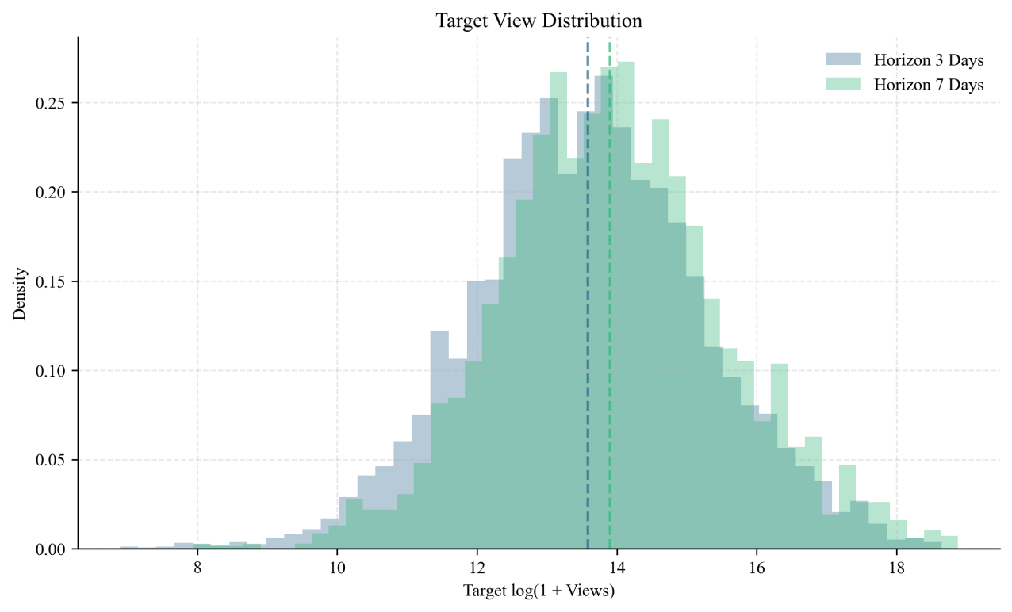
Figure 1. Target View Distribution

As shown in Figure 2, the Pearson correlation coefficients of main variables in the H=3 sample are given. The correlation coefficient between the log-transformed view count on Day 3 and the log-transformed target views becomes 0.992, while early likes and comments are also highly correlated with popularity later. These phenomena suggest that the signals in historical exposure and user engagement are useful for future dissemination. However, a high correlation coefficient does not mean that the task can be classified linearly based on one variable. As indicated in Figure 3, even if the future views have large variations in videos with the same initial view counts, especially in medium and high popularity groups. The persistence prediction method using only one previous observation cannot represent the whole process of the growth. Thus, the model needs to consider both video features, feedback information, and temporal factors as well as to learn the nonlinearity relationship among many variables. Through above analyses, it is evident that the Youtube popularity prediction problem is simultaneously influenced by the long-tailed distribution, the nonlinearity of interaction features, and the selection effect on the platform. The following experiments thus perform the logarithmic transformation and consider the interaction sequence as well as the video content features in the same time period.

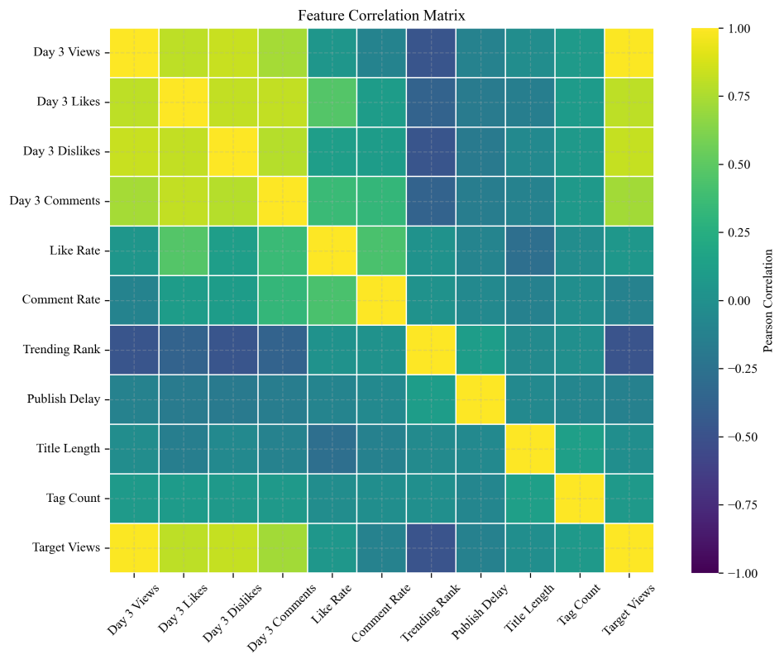
Figure 2. Feature Correlation Matrix
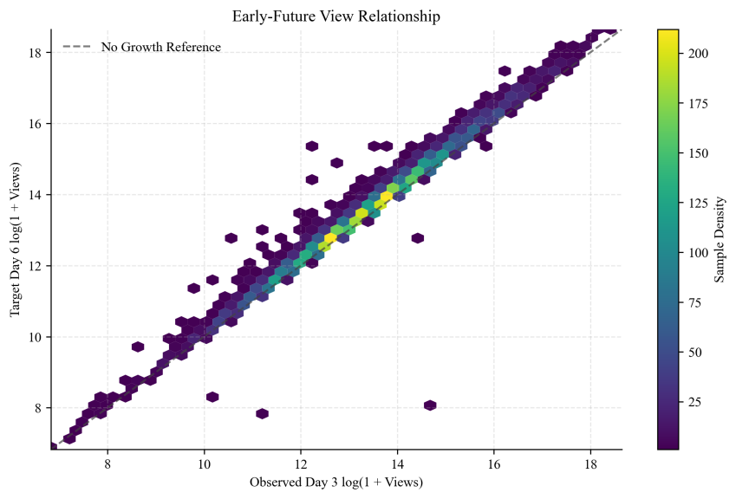
Figure 3. Early-Future View Relationship

3.3 Experimental Design
Experiment procedure comprises the prediction of the popularity of videos available at YouTube. First of all, the dataset which contains raw data of the videos is cleaned up by cleaning, anomaly detection, standardization of time features, duplication elimination, and missing values/outliers treatment. After that, the measures of video popularity are computed according to the interaction features such as views, likes, and comments. Finally, the feature extraction is conducted according to the features of the videos, interaction features, and time features. The last part of the experiment procedure is normalization of numeric features and propagation sequence organization using a time window.
During the training of the model, GWO first searches for the optimal hyperparameters of the Transformer model, such as learning rate, the number of attention heads, hidden dimension, the number of layers in the encoder, and batch size. After that, the transformer is trained with the determined parameters to make predictions regarding video popularity. The evaluation of the efficiency of the developed model is conducted by comparing it with ARIMA, Random Forest, XGBoost, LSTM, and transformer models. MAE, RMSE, MAPE, and R² are used as criteria for evaluation. Also, ablation studies are conducted to determine the role of GWO optimization in the proposed model, and the convergence curve is analyzed.

4 Results and Analysis

4.1 Model Comparison
The current section begins with an analysis of model performance on the test set with respect to the short-term forecast H=3. Propagation dynamics based on the first three observation days are applied in all models. The same chronologically split dataset is employed for this case. There are 536 observations in the test set, hence, all deviations from the benchmarks in Table 2 are determined by the model architecture and optimization. One can observe that the classical Ridge model demonstrates the best results in terms of MAE and RMSE with the values of 0.0905 and 0.1269, correspondingly, and R² = 0.9911. LightGBM comes second with RMSE of 0.1361. In comparison with the benchmark, Ridge reduces RMSE by 58.86%.
Table 2. Model Comparison
Model | MAE | RMSE | sMAPE (%) | R2
Persistence | 0.2482 | 0.3083 | 24.4211 | 0.9473
Ridge | 0.0905 | 0.1269 | 9.0044 | 0.9911
LightGBM | 0.0951 | 0.1361 | 9.4570 | 0.9897
LSTM | 0.1296 | 0.1719 | 12.8680 | 0.9836
Transformer | 0.1202 | 0.1771 | 11.8986 | 0.9826
PSO-Transformer | 0.1142 | 0.1667 | 11.3282 | 0.9846
GWO-Transformer | 0.1278 | 0.1762 | 12.6763 | 0.9828

As Figure 4 shows, the benefits of Ridge and LightGBM strongly depend on the length of the observation window. Indeed, the input sequence contains only three days of propagation, and the target views have high correlation with the views at Day 3. Under such setting, the linear approach is able to use the robust relationship between the cumulative exposure and engagement, while the tree-based algorithm identifies more complex thresholds. Recurrent and attention models have to learn more complex embeddings from a limited number of steps; their parameterization is not perfectly tuned to the available temporal dimension, and thus these models are not better than the tabular approach yet. The results do not imply any lack of applicability of the sequence models under a larger number of days to predict or forecast the number of views.

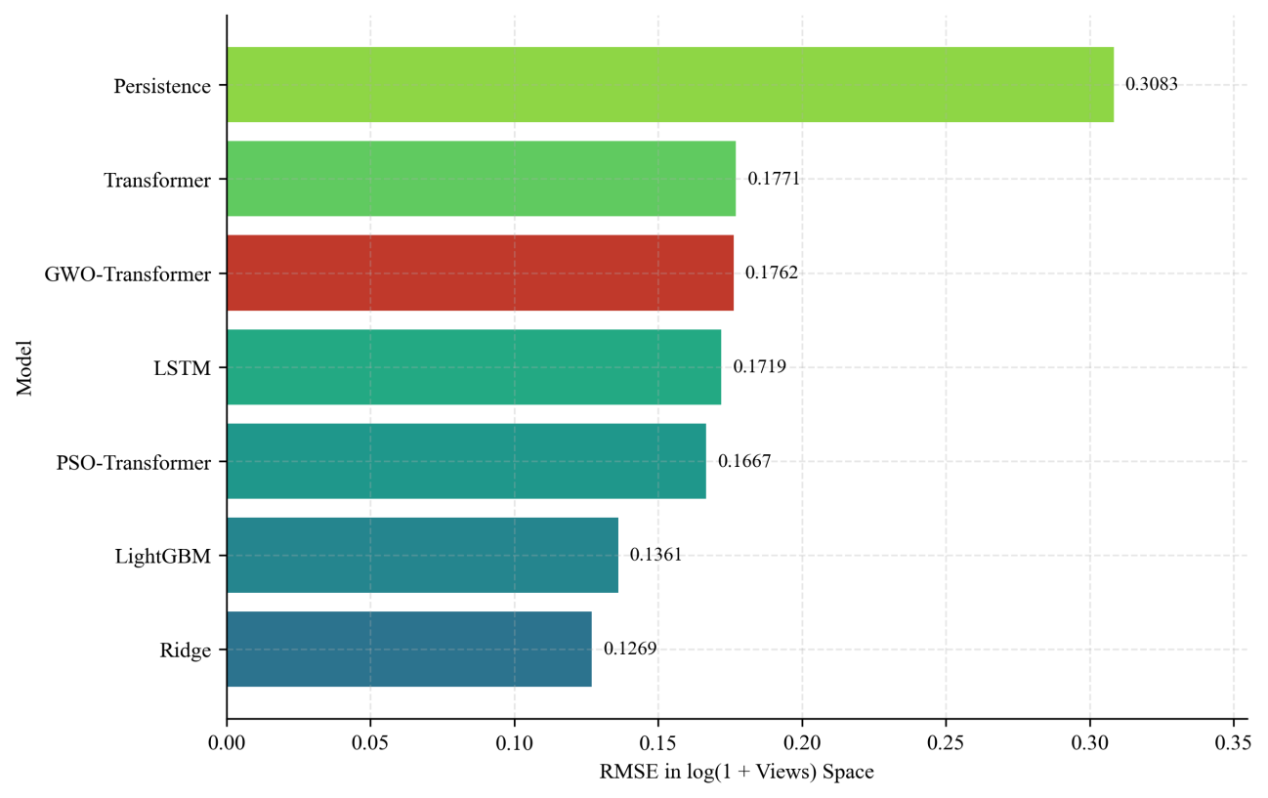
Figure 4. Model Comparison

4.2 Hyperparameter Optimization
Validation set RMSE is chosen as the objective function and GWO runs for nine configurations of parameters, where each configuration is evaluated in a scenario of three candidate wolves for three iterations. Figure 5 depicts the progression of the best validation loss through iterations. The best RMSE drops from 0.3509 in the first iteration to 0.3380 in the second, which corresponds to a drop of 3.66% in total, while being constant in the third iteration. Thus, one can conclude that the optimization process finds a particular combination of the parameters that works better for this data compared to the initial configurations.
Table 3. Selected Hyperparameters
Model | Model Dimension | Attention Heads | Encoder Layers | Dropout | Learning Rate | Best Epoch
Transformer | 48 | 4 | 1 | 0.1500 | 0.001000 | 21
PSO-Transformer | 48 | 2 | 2 | 0.1052 | 0.003303 | 21
GWO-Transformer | 48 | 4 | 2 | 0.0622 | 0.001483 | 13

As seen in Table 3, the configuration identified by GWO changes the number of encoder layers from 1 to 2, decreases dropout from 0.1500 to 0.0622, and sets the learning rate to 0.001483. The optimization process helps the selected configuration reach the early stopping criterion much earlier (13 epochs as opposed to 21 for the original Transformer), but the training still stops at epoch 13 on the validation dataset. On the test dataset, GWO-Transformer outperforms unoptimized Transformer with RMSE 0.1762 as against 0.1771, which is a 0.50% difference in favor of GWO-Transformer, and with R² growing from 0.9826 to 0.9828. Therefore, in the present settings, GWO finds a more suitable parameter space and delivers observable benefits in squared error. However, the stability of the model needs to be checked further.

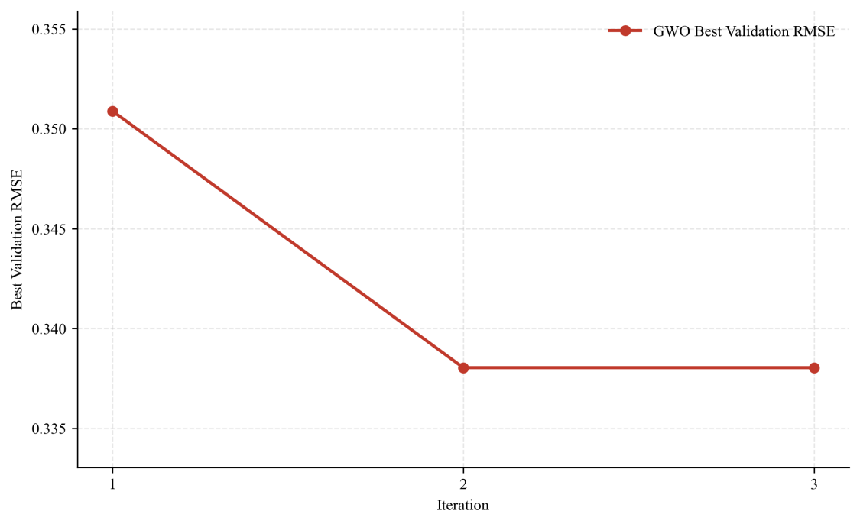
Figure 5. GWO Convergence

4.3 Ablation Study
In order to evaluate the impact of the selected hyperparameter optimization approach, Table 4 offers the comparative results for an unoptimized transformer, PSO-Transformer, and GWO-Transformer on the same inputs and testing protocols as employed by the Transformer. Specifically, the RMSE for the unoptimized transformer is 0.1771, which is decreased to 0.1762 by GWO-Transformer, resulting in 0.50% relative reduction. As for PSO-Transformer, it has the RMSE of 0.1667, which is 5.87% less than that of the unoptimized Transformer. Moreover, all three models utilize attention encoder; therefore, the presented comparison reflects only the differences in hyperparameter optimization approaches and hyperparameters and does not include any other differences in feature engineering and data splitting. The relatively small reduction in the RMSE of GWO-Transformer indicates that the grey wolf search is efficient. Nevertheless, the MAE and sMAPE values of GWO-Transformer are 0.1278 and 12.6763, respectively, which are both higher compared to the unoptimized Transformer, and the model is unable to achieve the same level of accuracy as PSO-Transformer under the given conditions. Hence, the advantage of GWO search lies in the improvement in RMSE metric rather than in the superiority in all three metrics. It may happen because of the insufficient number of days in the sequence of data for structural optimization, the limited budget for the optimization process, and the focus on RMSE value in the objective function.
Table 4. Optimizer Ablation
Model | MAE | RMSE | sMAPE (%) | R2
Transformer | 0.1202 | 0.1771 | 11.8986 | 0.9826
PSO-Transformer | 0.1142 | 0.1667 | 11.3282 | 0.9846
GWO-Transformer | 0.1278 | 0.1762 | 12.6763 | 0.9828

5 Conclusion
This paper aims to address the issue of complexity in temporal dependencies, nonlinearity in patterns of change, and limitations of the existing models applied in predicting future features of videos' popularity on YouTube. This paper is presented as a prediction model that uses the integration of the Grey Wolf Optimizer (GWO) and the Transformer model, termed as GWO-Transformer. The method involves the use of self-attention in the Transformer model to learn deep temporal features of the propagation of the videos.
Based on the experimental study and validation of the model with existing approaches, it can be seen that the designed GWO-Transformer model is capable of capturing the dynamics of YouTube video popularity and exhibits good accuracy and generalization for the prediction task. In comparison with the conventional machine learning algorithms and unoptimized deep learning models, the proposed approach is able to better capture the long dependencies within video popularity sequences and minimize prediction errors.
In this paper, a new methodology is introduced for the study of the dissemination patterns of videos in video sharing websites and has some value in the area of optimizing video recommendation, user behavior analysis, and intelligent management of the platform. For future research studies, one can think about making use of multidimensional data where the features will include those of video content, user behavior, and social networking structure to form multimodal models.

References
[1] F. Figueiredo, F. Benevenuto, and J. M. Almeida, “The tube over time: Characterizing popularity growth of YouTube videos,” in Proc. ACM WSDM, 2011, pp. 745-754.
[2] H. Pinto, J. M. Almeida, and M. A. Gonçalves, “Using early view patterns to predict the popularity of YouTube videos,” in Proc. ACM WSDM, 2013, pp. 365-374.
[3] T. Trzcinski and P. Rokita, “Predicting popularity of online videos using support vector regression,” IEEE Trans. Multimedia, vol. 19, no. 11, pp. 2561-2570, 2017.
[4] M. U. Nisa, D. Mahmood, G. Ahmed, S. Khan, M. A. Mohammed, and R. Damaševičius, “Optimizing prediction of YouTube video popularity using XGBoost,” Electronics, vol. 10, no. 23, 2021.
[5] Y. Mao, Y. Shen, G. Qin, and L. Cai, “Predicting the popularity of online videos via deep neural networks,” arXiv preprint arXiv:1711.10718, 2017.
[6] B. Wu, W.-H. Cheng, Y. Zhang, Q. Huang, J. Li, and T. Mei, “Sequential prediction of social media popularity with deep temporal context networks,” in Proc. IJCAI, 2017, pp. 3062-3068.
[7] D. Liao, J. Xu, G. Li, W. Huang, W. Liu, and J. Li, “Popularity prediction on online articles with deep fusion of temporal process and content features,” in Proc. AAAI Conf. Artificial Intelligence, vol. 33, no. 1, 2019, pp. 200-207.
[8] K. Ding, R. Wang, and S. Wang, “Social media popularity prediction: A multiple feature fusion approach with deep neural networks,” in Proc. ACM Multimedia, 2019, pp. 2682-2686.
[9] B. Wu, P. Liu, W.-H. Cheng, B. Liu, Z. Zeng, J. Wang, Q. Huang, and J. Luo, “SMP Challenge: An overview and analysis of social media prediction challenge,” in Proc. ACM Multimedia, 2023.
[10] A. Vaswani et al., “Attention is all you need,” in Proc. NeurIPS, 2017, pp. 5998-6008.
[11] H. Zhou, S. Zhang, J. Peng, S. Zhang, J. Li, H. Xiong, and W. Zhang, “Informer: Beyond efficient transformer for long sequence time-series forecasting,” in Proc. AAAI Conf. Artificial Intelligence, vol. 35, no. 12, 2021, pp. 11106-11115.
[12] H. Wu, J. Xu, J. Wang, and M. Long, “Autoformer: Decomposition transformers with auto-correlation for long-term series forecasting,” in Proc. NeurIPS, 2021.
[13] S. Mirjalili, S. M. Mirjalili, and A. Lewis, “Grey wolf optimizer,” Advances in Engineering Software, vol. 69, pp. 46-61, 2014.
[14] H. Song, J. Dai, H. Sheng, and J. Wang, “Grey wolf optimization-based deep echo state network for time series prediction,” Frontiers in Energy Research, vol. 10, 2022.

